select \* from salgrade;

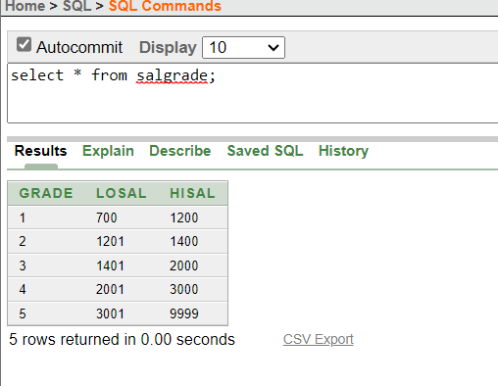

select deptno From dept;

select ENAME, SAL,SAL\*.05 AS "INCREMENT" FROM emp;

select ENAME, SAL+SAL\*.05 AS "INCREMENT" FROM emp;

Select \* FROM emp where ENAME = 'BLAKE';

Select ename || ' ' || 'is hired on ' || 'as a ' || job AS "Employee Hiredate" from emp;

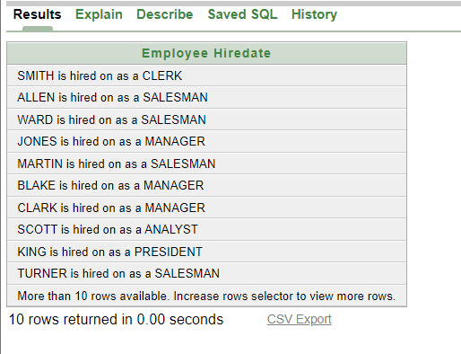

describe dept;

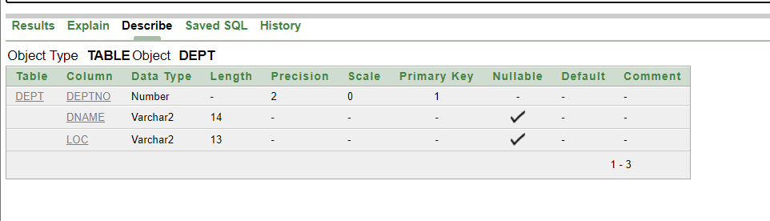

describe emp;

describe bonus;

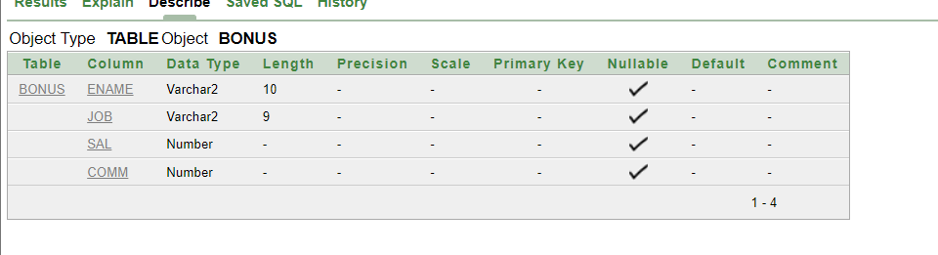

describe salgrade;

Select DISTINCT job from emp;

